Caroline

<http://nursejournal.org/community/ut-arlington-helps-nursing-shortage-and-military-vets-with-fed-funded-program/>

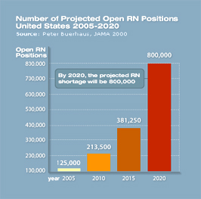

Lauren Hutchison

<http://thesocietypages.org/socimages/2012/08/29/>

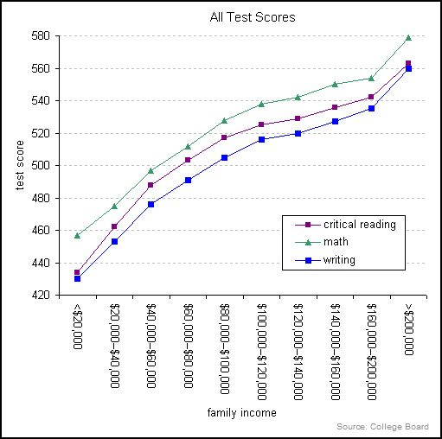

Sally Han

<http://www.wsj.com/articles/u-s-treasury-reports-2-billion-surplus-in-december-1421176136>

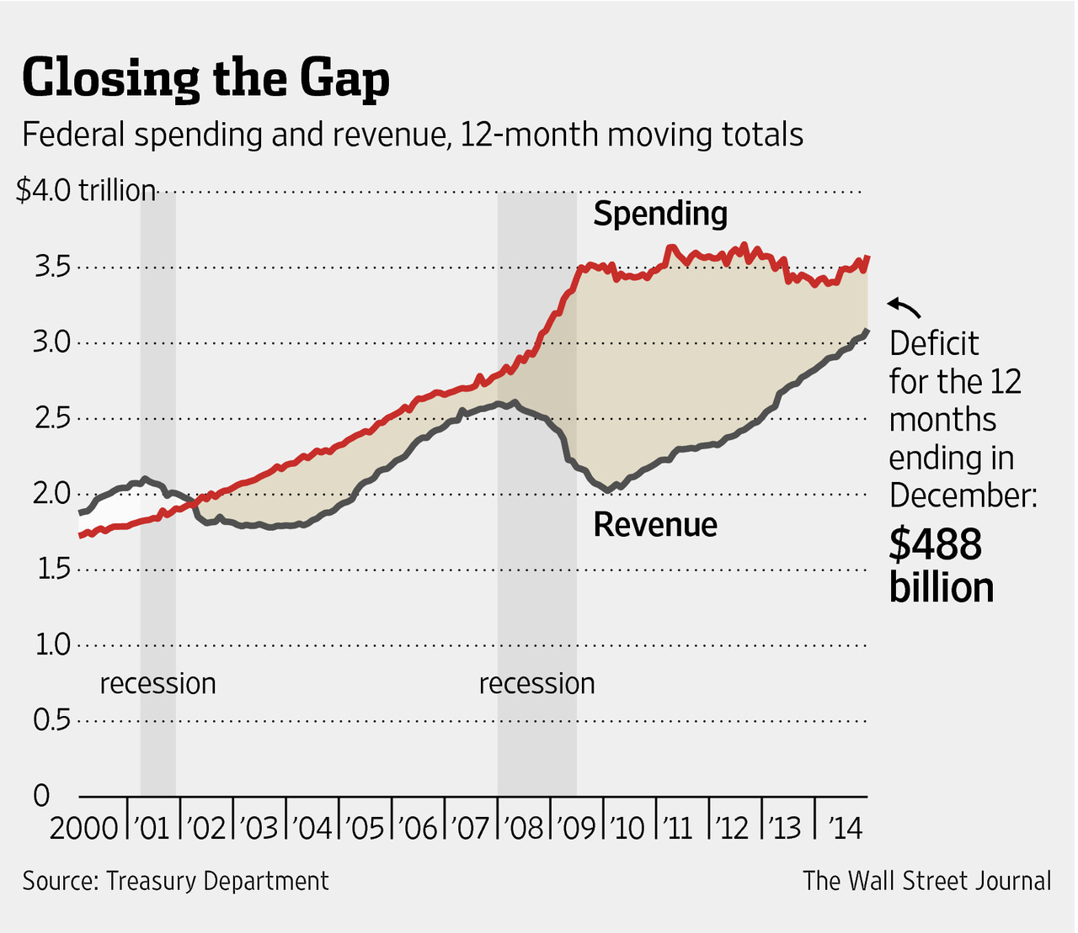

Chelsea Conway

<http://www.tacanow.org/family-resources/latest-autism-statistics-2/>

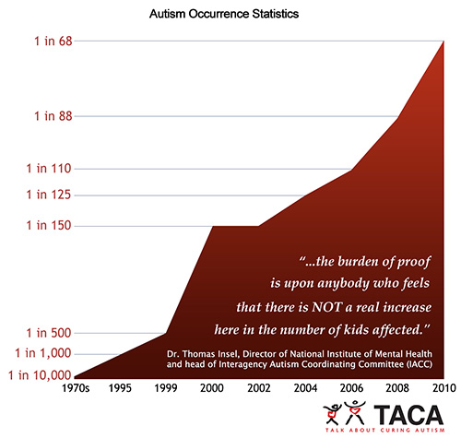

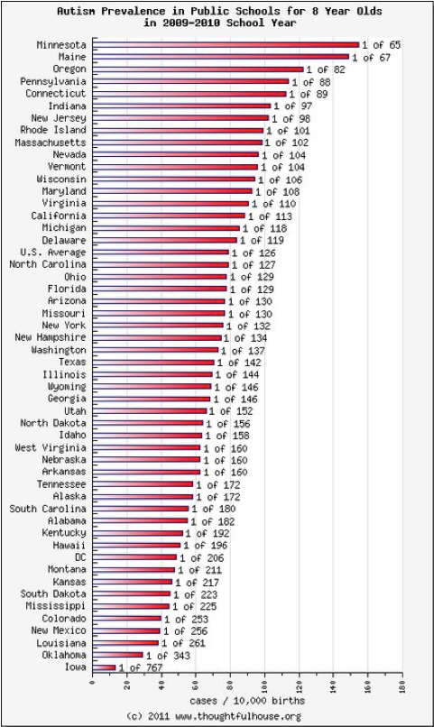

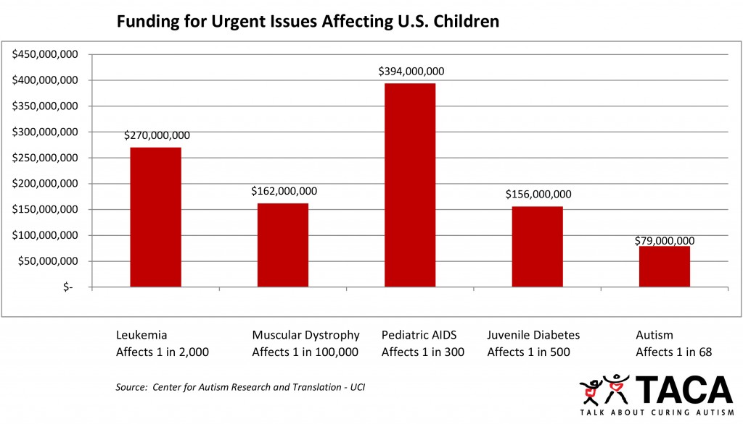

Suzanna Fletcher

<http://www.extremetech.com/mobile/197346-google-throws-nearly-a-billion-android-users-under-the-bus-refuses-to-patch-os-vulnerability>

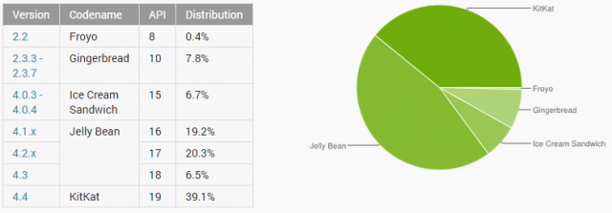

Tammi Hayes

<http://mobile.nytimes.com/2014/12/14/upshot/us-employment-women-not-working.html>

(could not copy image)

Diana DeBernardis

<http://www.wisconsincenterfornursing.org/nursing_survey.html>

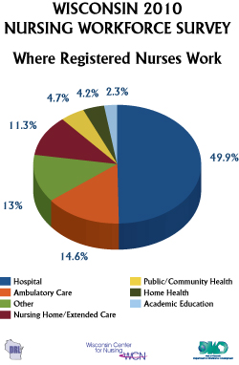

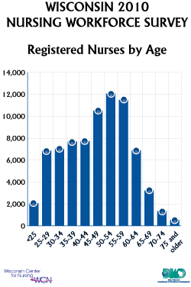

Amelia McLoren

<http://thesocietypages.org/socimages/2013/07/17/on-racial-profiling/>

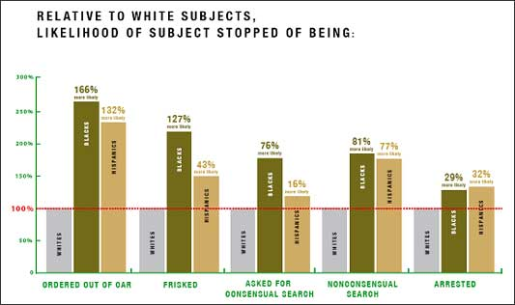

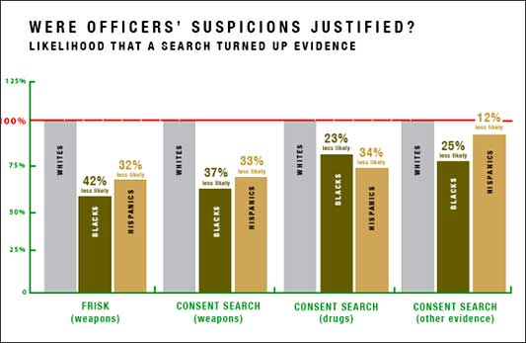

Ashlea-Anne Rosnick

<http://www.huffingtonpost.com/2014/03/06/raising-sat-score_n_4907444.html>

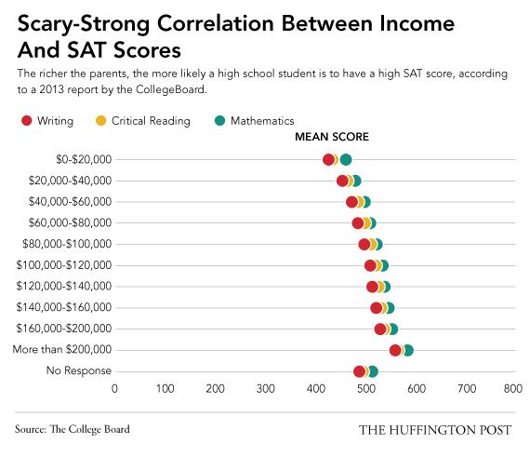

Lorenza Schwartzmiller

<http://www.nytimes.com/interactive/2014/07/31/world/africa/ebola-virus-outbreak-qa.html>

(could not copy images)

